**FINAL PROJECT ALGORTIMA DAN PEMROGRAMAN**

**BIOSKOP WEEKEND ASIX**



**DOSEN :**

MAJID RAHARDI, S.KOM., M.ENG

**KELOMPOK 6 :**

KOMANG NITAY PRASADDAS 21.11.4376

DENI RAHMAN MASULILI 21.11.4377

SONNY WAHYU SETIAWAN 21.11.4378

MUHAMMAD ARTHERIO C. 21.11.4379

RICHARDO UMBU SIWA D. S. 21.11.4380

ARIC YOHANES 21.11.4381

NUR AZZIZAH 21.11.4382

FAJAR KURNIAWAN 21.11.4383

ANGGA AIRUL ROHMAN 21.11.4384

**PROGRAM STUDI SARJANA INFORMATIKA**

**FAKULTAS ILMU KOMPUTER**

**UNIVERSITAS AMIKOM YOGYAKARTA**

**2021/2022**

**PENDAHULUAN**

Dalam Final Project kelompok kami membuat program BIOSKOP WEEKEND ASIX. Pada saat ini, semakin banyak orang yang ingin menonton bioskop apalagi setelah pandemi Covid-19 yang melarang masyarakat untuk pergi ke bioskop. Dengan meningkatnya masyarakat yang ingin menonton bioskop maka diperlukan sistem atau suatu program untuk mempermudah masyarakat, sehingga kelompok kami membuat program BIOSKOP WEEKEND ASIX. Program ini dibuat dengan tujuan untuk mempermudah dalam pemesanan tiket bioskop dan customer dapat memilih film, jam tayang, tempat duduk, serta makanan yang tersedia di bioskop tersebut.

**FITUR**

Dalam Final Project milik kami, secara garis besar terdapat 6 fitur yang berhasil kami rancang dan berhasil diaplikasikan di final project kami. Berikut penjelasannya :

* 1. Tampilan Beranda

Tampilan beranda berisikan tampilan pembuka yang terdapat pilihan untuk menuju 3 fitur lainnya.

* 1. Pemesanan Tiket

Di pemesanan tiket kami menampilkan fitur pemesanan tiket dengan konsep array pemilihan yaitu 4 pilihan film, 2 pilihan hari, 3 pilihan jam tayang, 3 ruang tonton dan 46 kursi yang siap dipesan oleh pelanggan. Dengan kata lain akan terdapat 72x penayangan film dalam 2 hari dan 3.312 kursi berbeda yang siap di pesan untuk menonton film.

Yang menarik dari bagian ini adalah saat pelanggan sampai di bagian pemilihan nomor kursi, akan muncul replika denah kursi yang menjadi acuan untuk memilih kursi. Jika pelanggan berikutnya memesan tiket yang bagian film, hari, jam tayang dan ruang yang sama maka nomor kursi yang dipilih pelanggan sebelumnya akan bertuliskan “SOLD” yang memberi informasi bahwa kursi itu sudah dipesan sebelumnya.

Kalian bisa melewati langsung ke pembayaran jika tak ingin memesan makanan

* 1. Pemesanan Makanan

Fitur pemilihan makanan yang terdiri dari 3 paket yang masing masing berisikan 3 jenis makanan didalamnya yang juga terdiri dari 3 pembagian seperti ukuran atau rasa atau combo. Dengan kata lain terdapat 27 jenis makanan yang disuguhkan di bagian ini.

pemesan bisa memesan makanan berulang jika pemesan memesan lebih dari satu jenis makanan. Dan langsung ke bagian pembayaran atau jika belum memesan tiket dan ingin memesan tiket bisa langsung ke pemesanan tiket.

* 1. Denah bioskop

Ini adalah fitur yang memperlihatkan replika denah bioskop agar pemesan tau pintu mana yang harus dimasukinya nanti.

* 1. Pembayaran

Di bagian ini kami akan menampilkan spesifikasi dari pesanan anda seperti judul filim, jam, hari, room dan nomor kursi serta total harga untuk pemesanan tiket.

Dan pada pemesanan makanan seperti nama makanan, jumlah pesanan, harga dan total harga makanan.

Dan terakhir total keseluruhan lalu dibagian akhir berisikan perintah tekan 1 dan enter untuk selesai dan program pun akan kembali menampilkan bagian beranda.

* 1. Fitur persiapan

Mungkin bisa disebut bukan fitur, dimana sebelum tampilan beranda ada sebuah pengisian nama judul film dan harga tiket yang berubah” setiap waktunya.

Untuk menghentikan looping(menghentikan penjuaan) dari program ini, di bagian akhir pembayaran jangan ketik 1 melainkan ketik “end” untuk mengakhiri atau ketik “cek” untuk melihat total penjualan dan omset penjualan.

**KERJA TIM**

Jadi dalam kelompok 6 ini kami melakukan sistem kerja sama dengan membagi tugas dimana ketua memberikan list tugas dan anggota bebas memilih tugas mana yang ingin di kerjakannya sesuai kemampuannya. Dan berikut hasil kerja tugas yang terjadi,

Tampilan beranda : Aric Yohanes

Tampilan pemesanan tiket : Nitay

Tampilan pemesanan makanan : Nur Azzizah, Artherio

Tampilan Denah Bioskop : Fajar Kurniawan

Tampilan Pembayaran : Angga Airul, Deni Rahman

Pengisian Dokumen Laporan : Artherio, Sonny

Penggabungan Program : Nitay

**FUNGSIONALITAS**

* Bagian persiapan awal sebelum penjualan

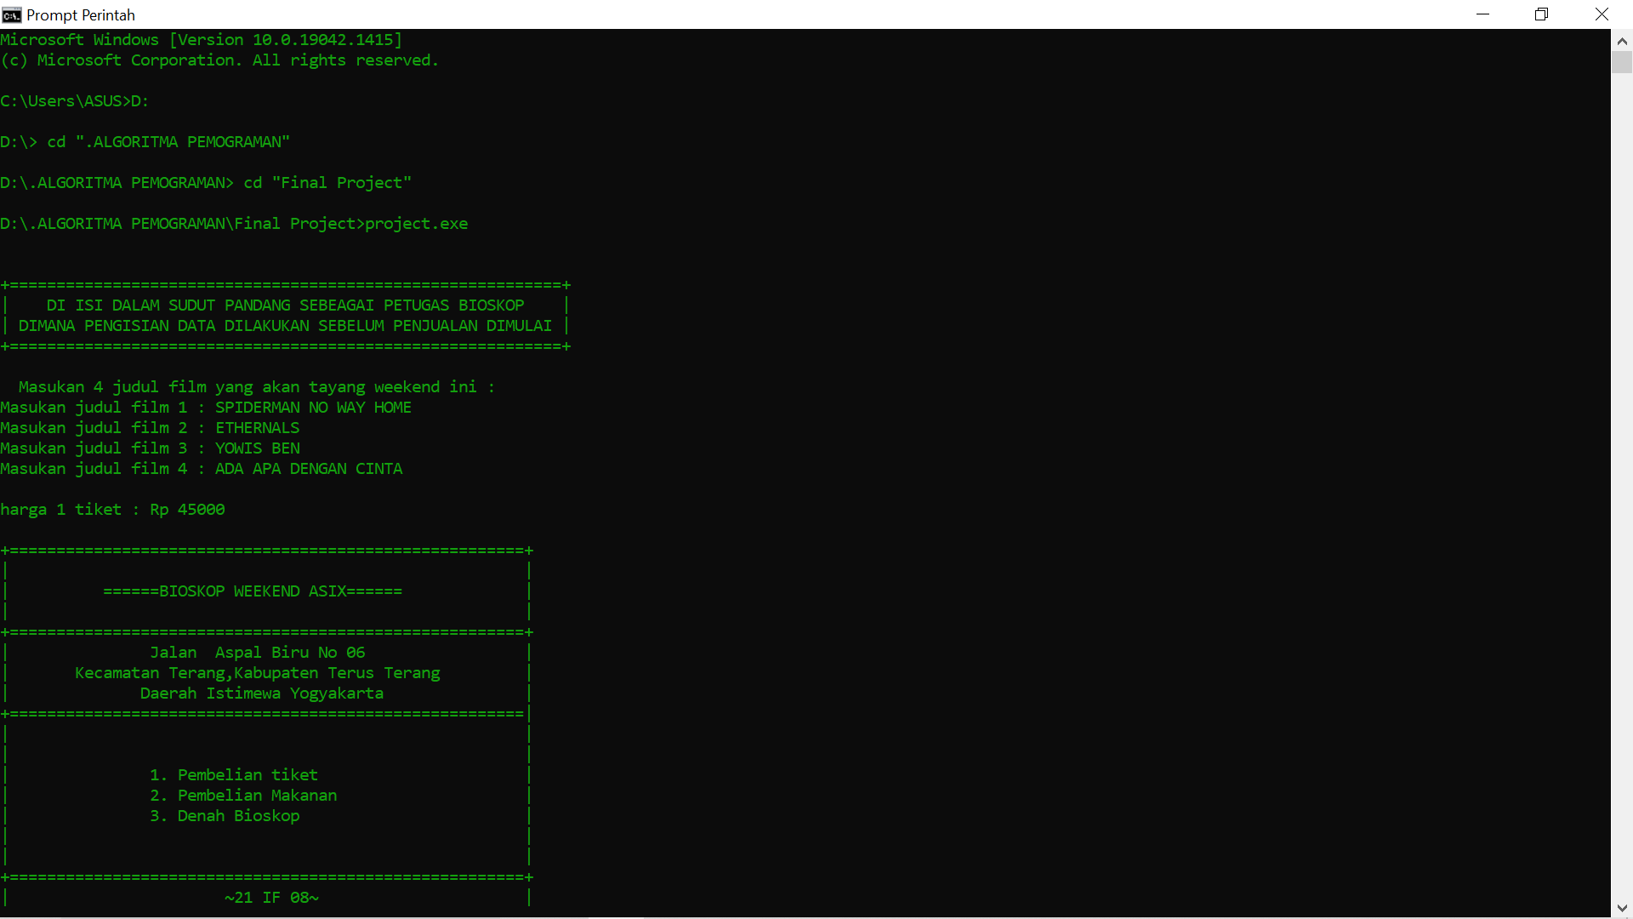

* Bagian beranda awal penjualan

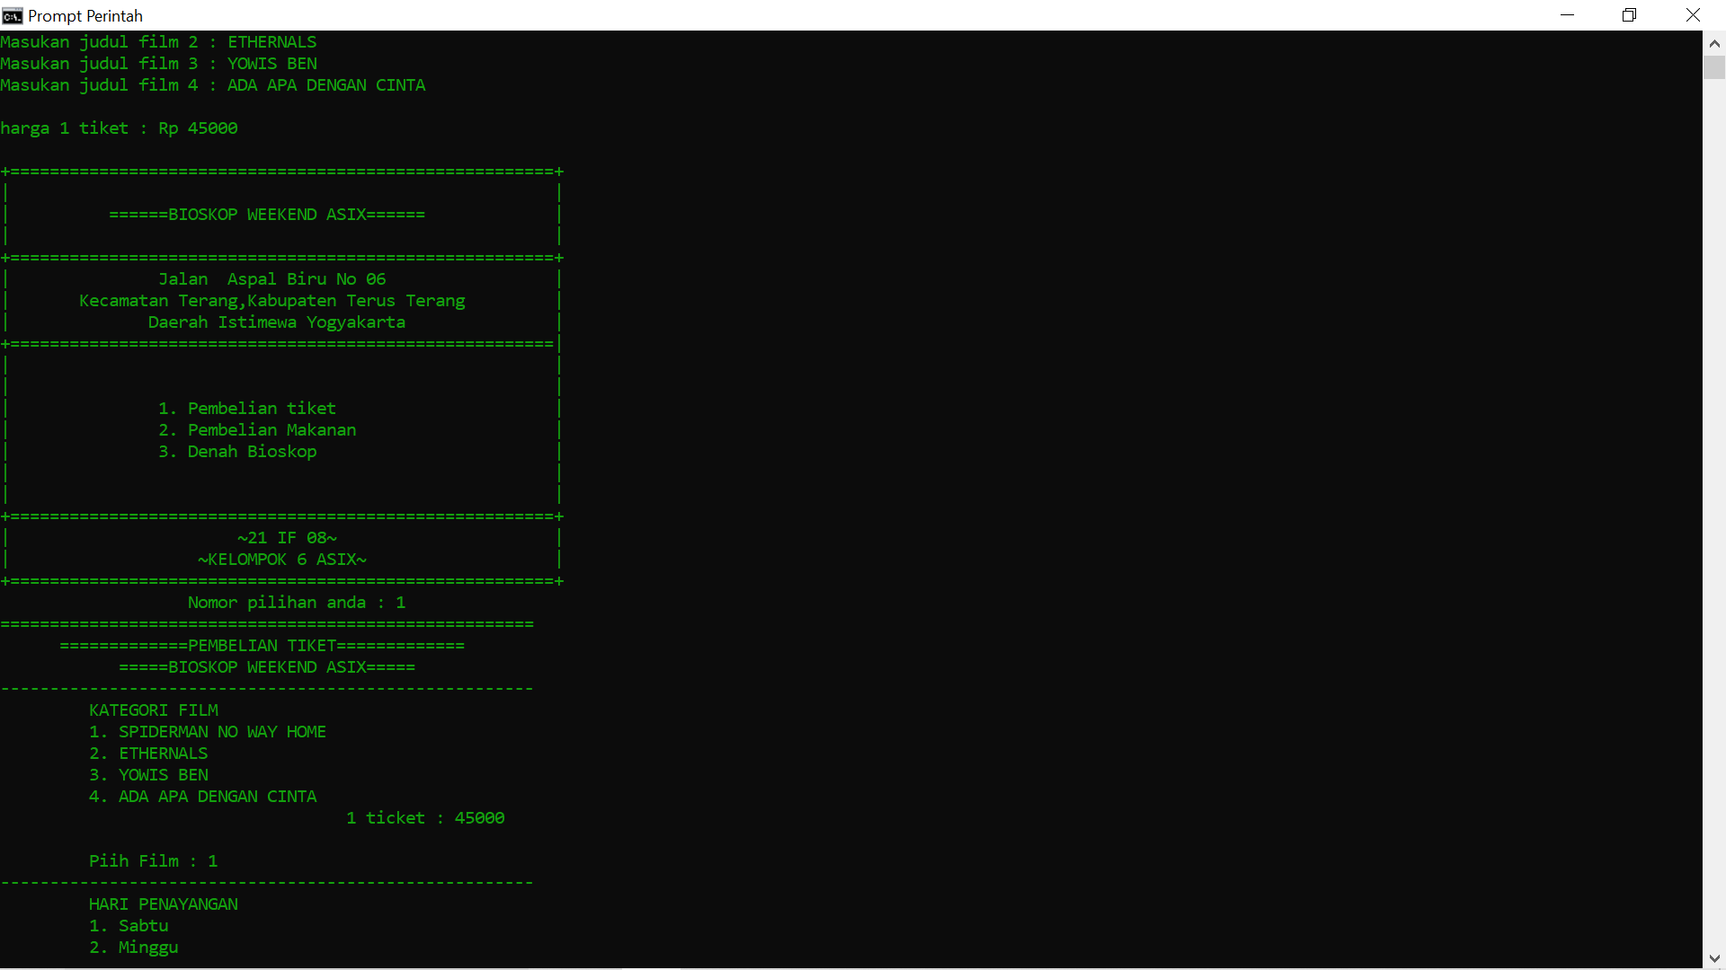

* Bagian penjualan tiket

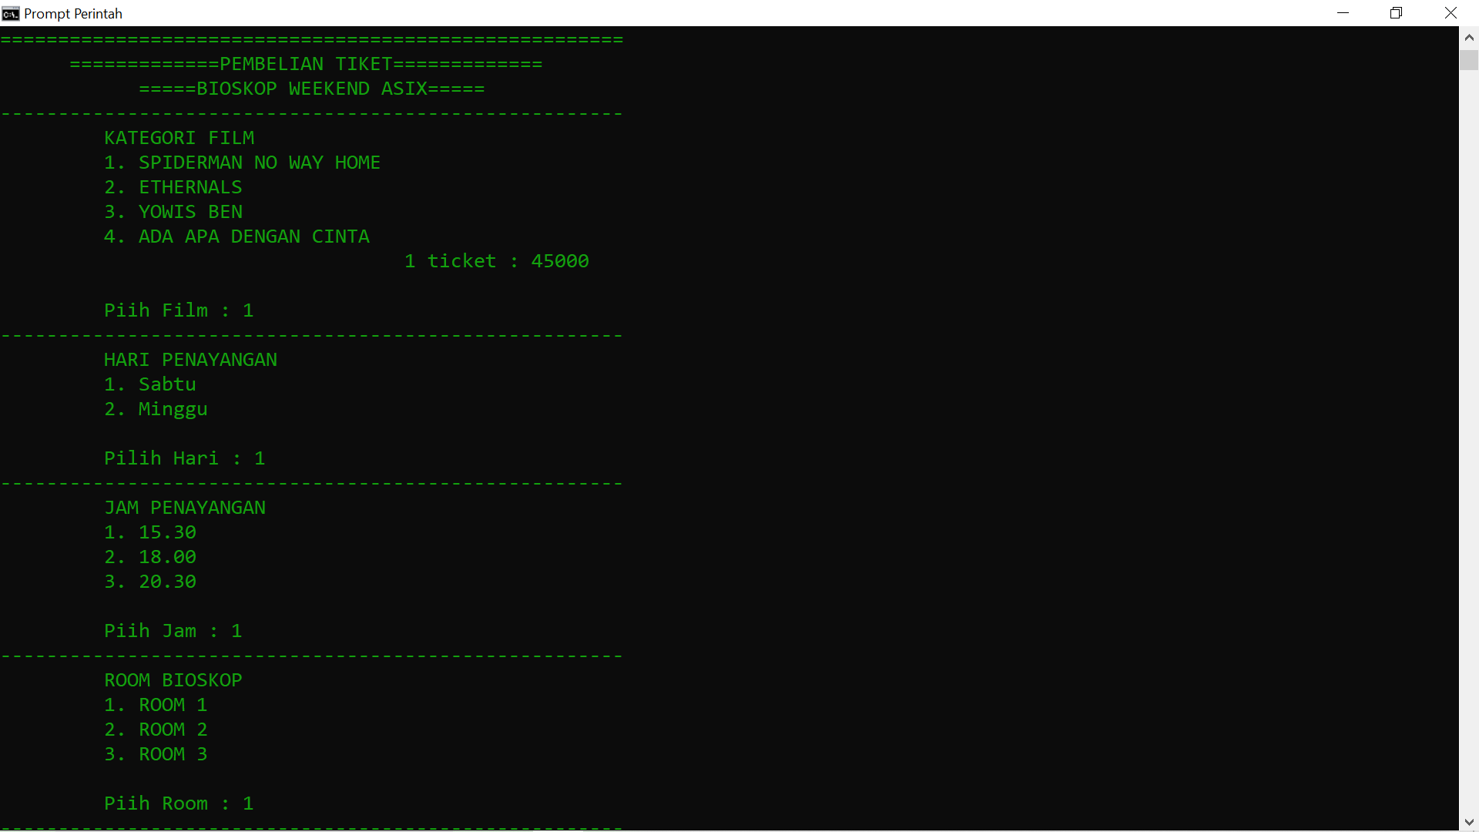

Perubahan sebelum dan sesudah terjual

Tampilan pembeli sebelumnya tampilan pada pembeli selanjutnya

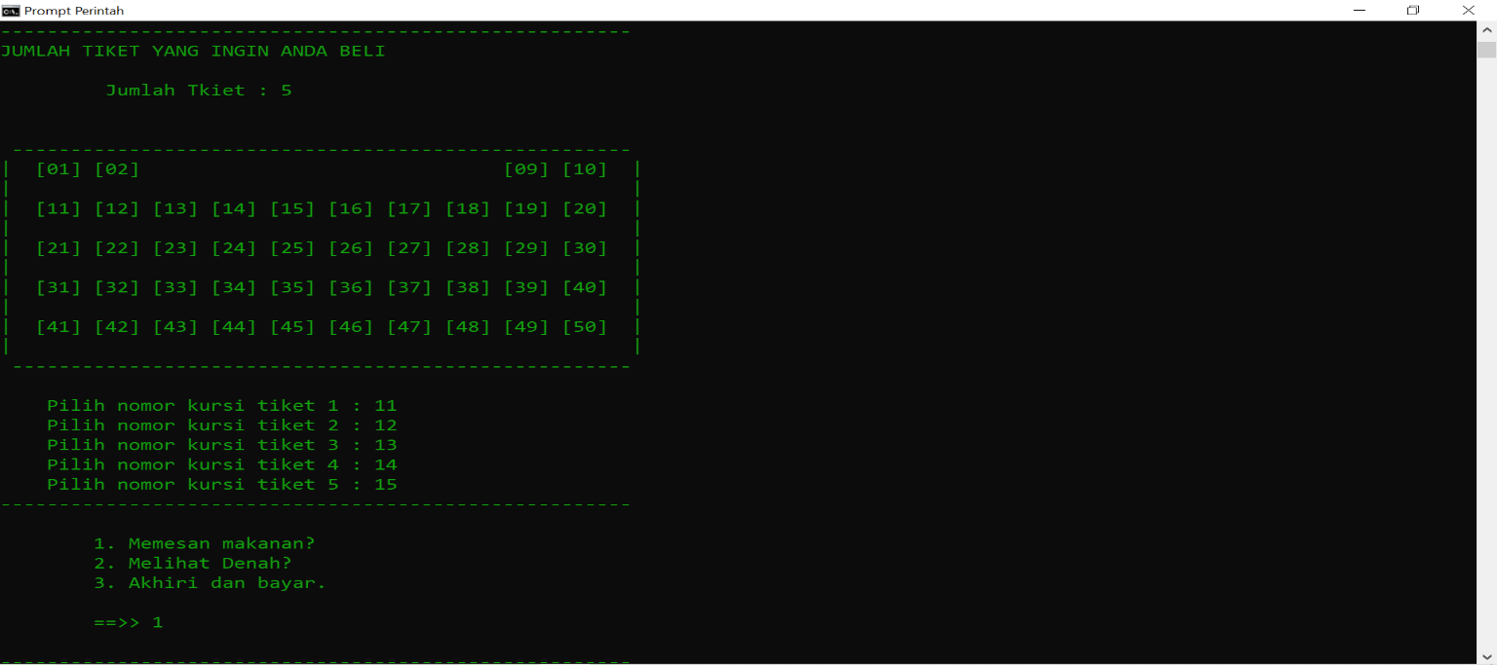 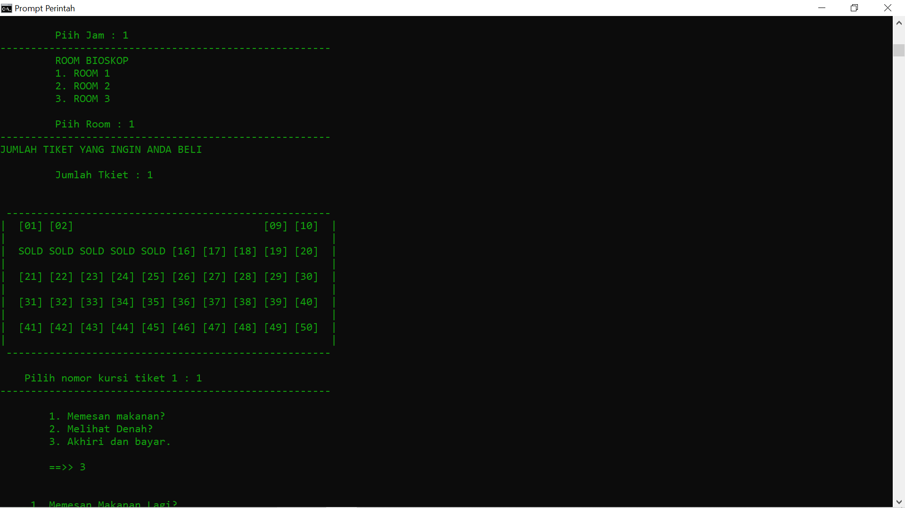

* Tampilan pemesanan makanan

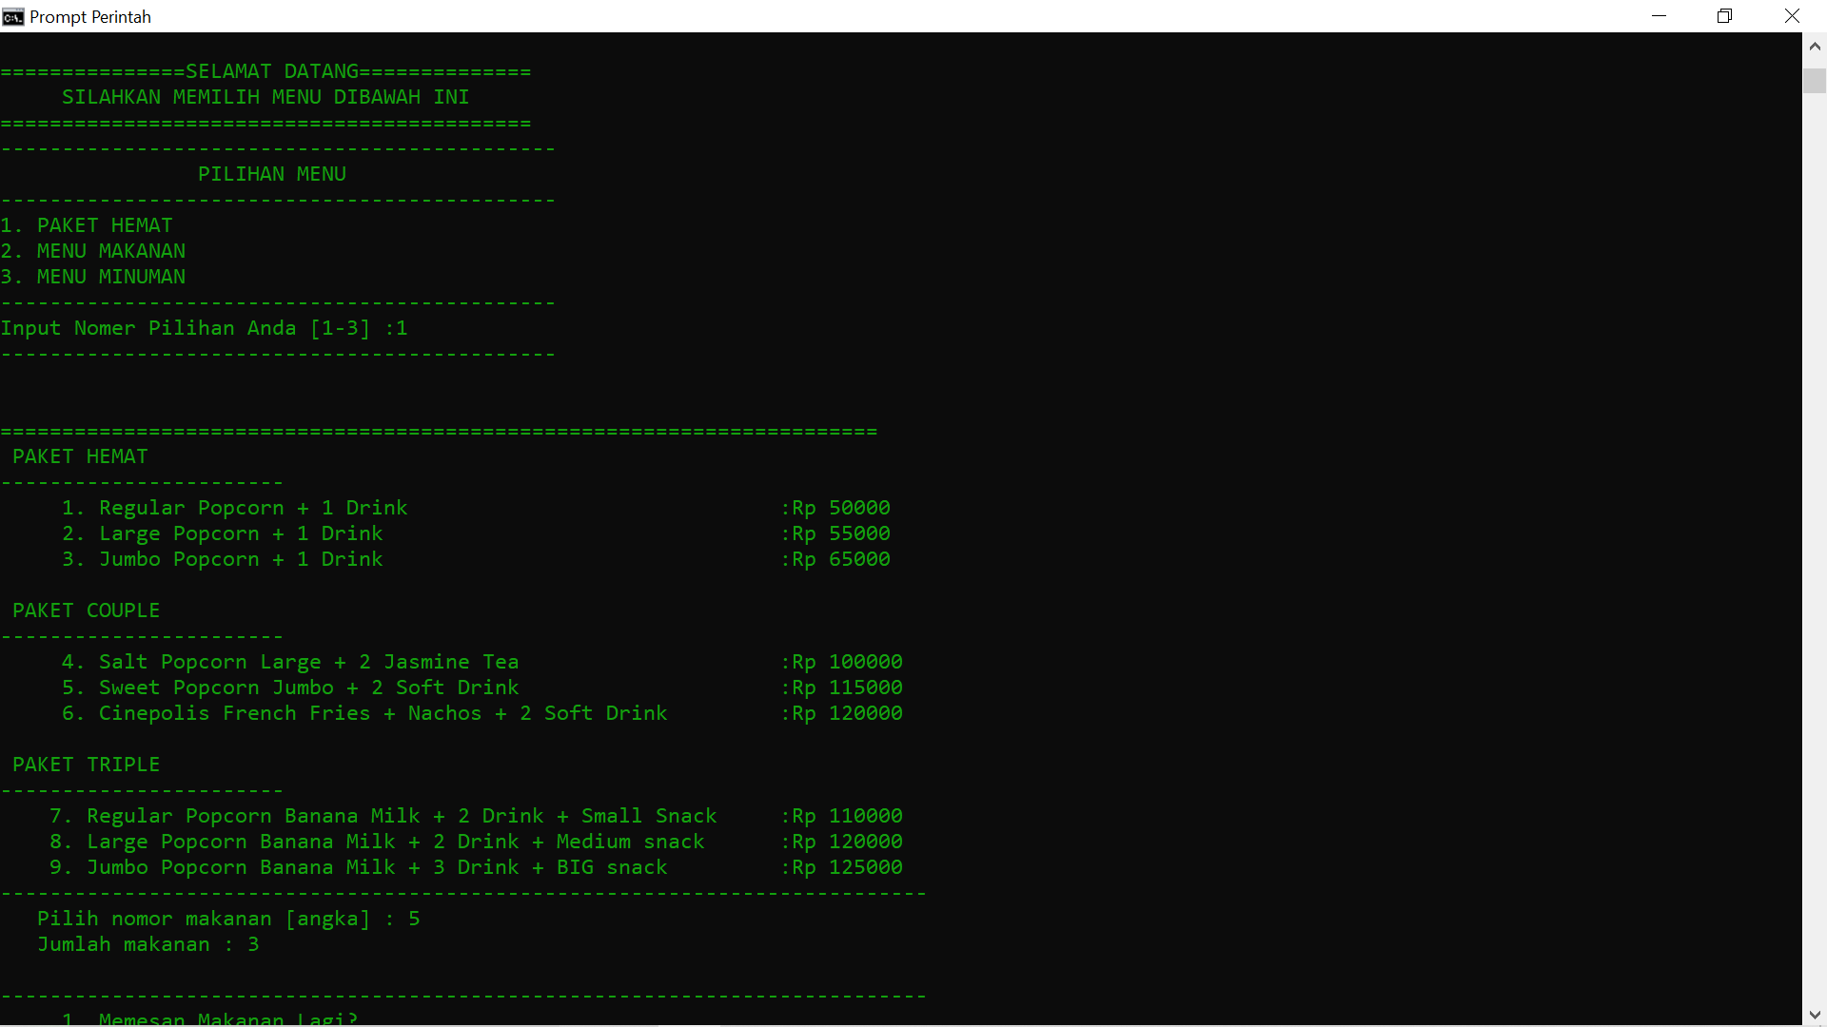

* Tampilan denah Bioskop

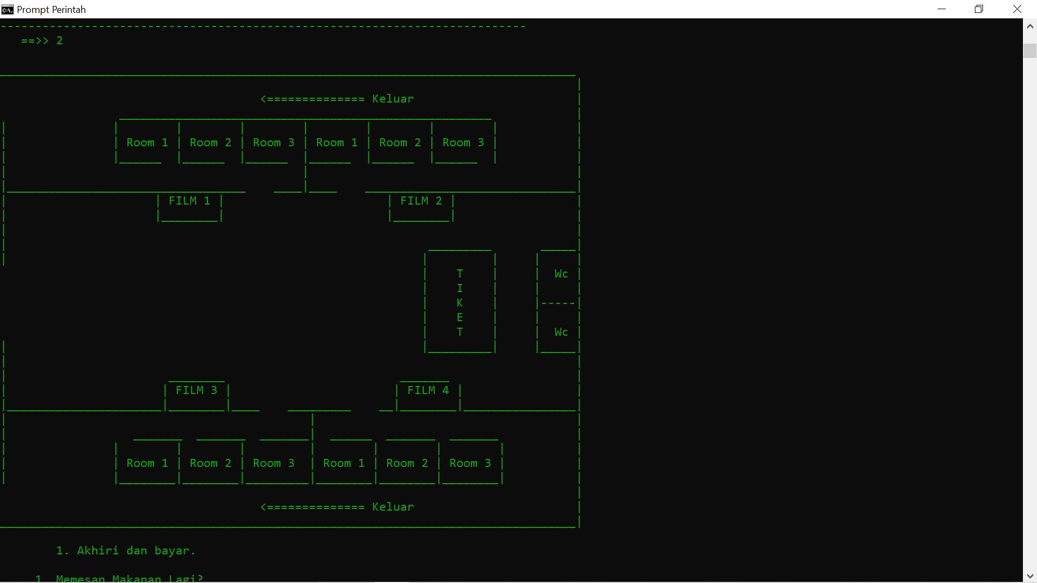

* Tampilan total pemesanan

(Tiket + Makanan)

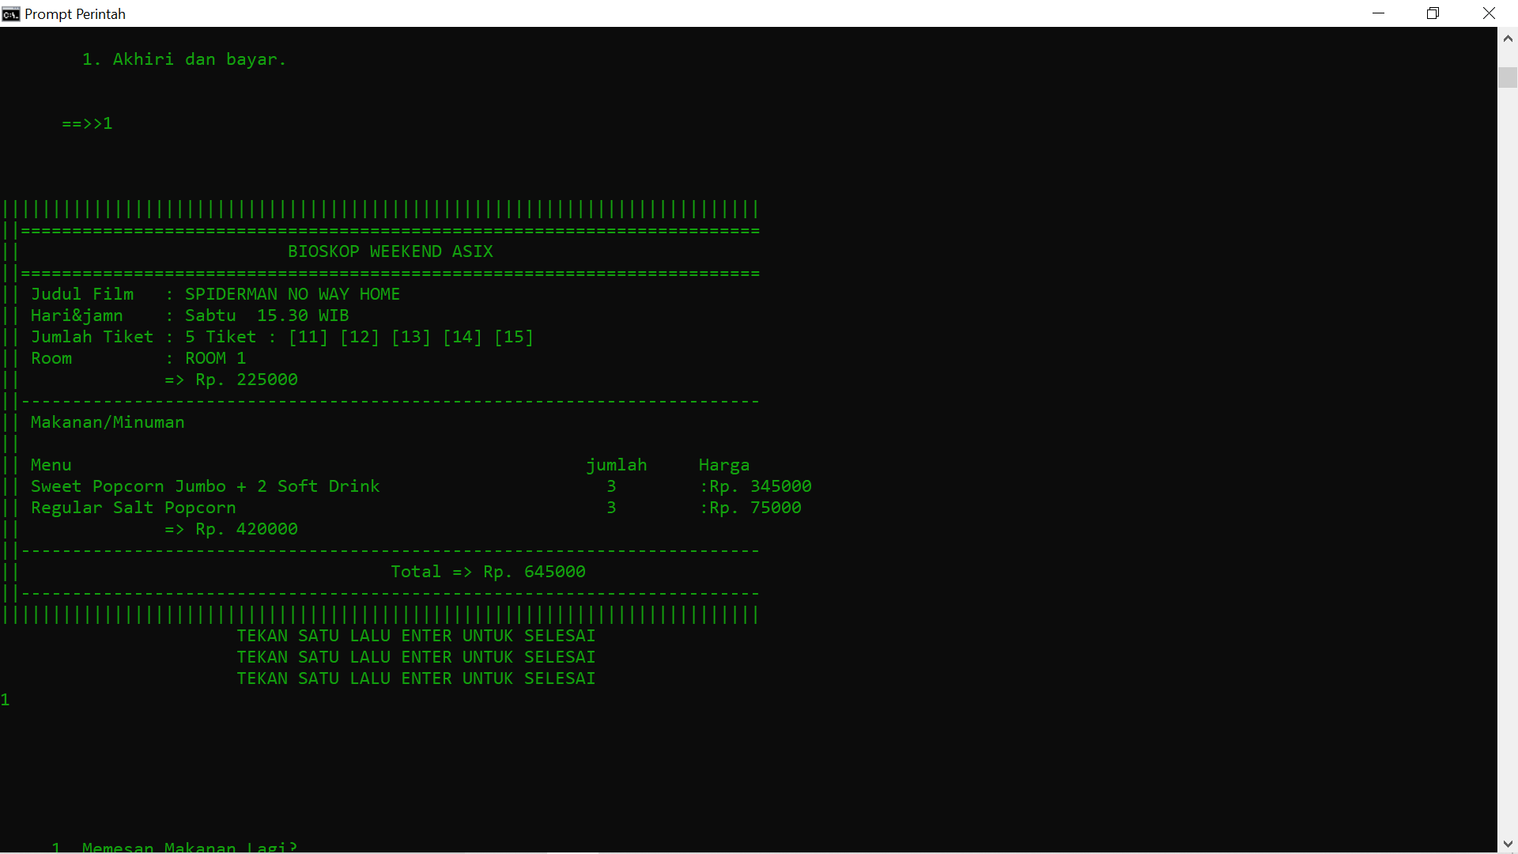

(Hanya Tiket)

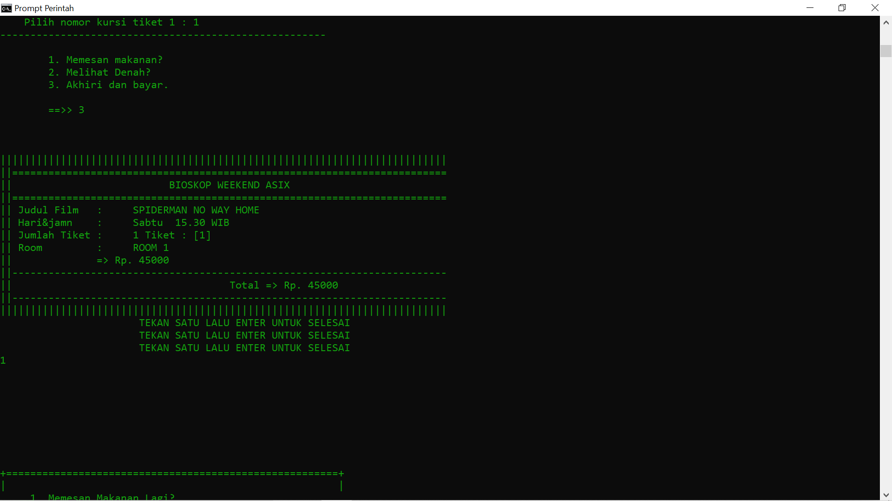

(hanya makanan)

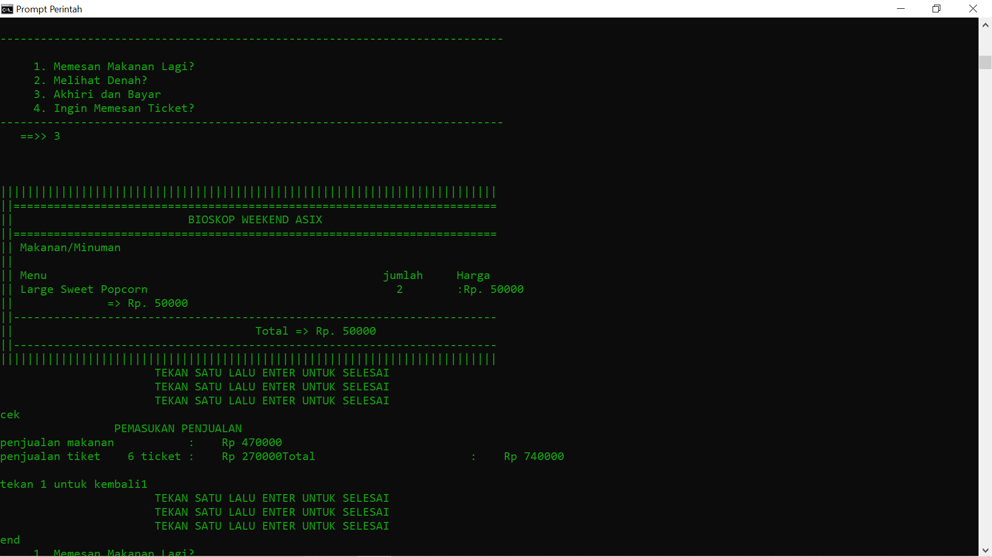

Tampilan total semua penjualan (cek & end)

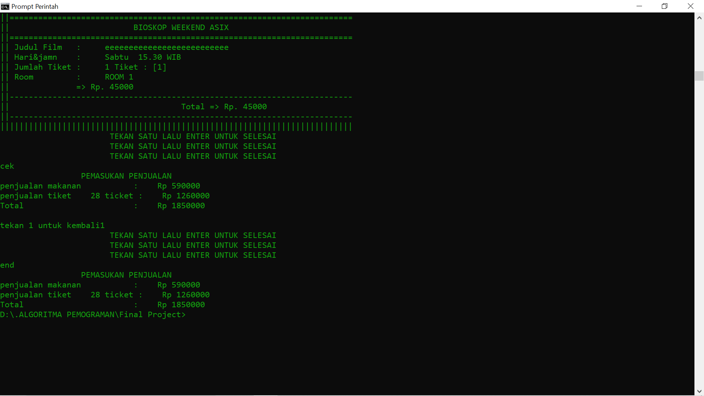

**KODE LENGKAP PROGRAM FP**

#include <iostream>

using namespace std;

int main() {

// #1 Persiapan Petugas

string kursi[4][2][3][3][50];

string Film [4];

string Hari [2]={"Sabtu ","Minggu "};

string Jam [3]={"15.30","18.00","20.30"};

string Room [3]={"ROOM 1","ROOM 2","ROOM 3"};

string Kursi[50] = {"[01]","[02]"," "," "," "," "," "," ","[09]","[10]","[11]","[12]","[13]","[14]","[15]","[16]","[17]","[18]","[19]","[20]","[21]","[22]","[23]","[24]","[25]"

,"[26]","[27]","[28]","[29]","[30]","[31]","[32]","[33]","[34]","[35]","[36]","[37]","[38]","[39]","[40]","[41]","[42]","[43]","[44]","[45]","[46]","[47]","[48]","[49]","[50]"};

string Produk[3][9]={{" Regular Popcorn + 1 Drink "," Large Popcorn + 1 Drink "," Jumbo Popcorn + 1 Drink ",

" Salt Popcorn Large + 2 Jasmine Tea "," Sweet Popcorn Jumbo + 2 Soft Drink "," Cinepolis French Fries + Nachos + 2 Soft Drink ",

" Regular Popcorn Banana Milk + 2 Drink + Small Snack "," Large Popcorn Banana Milk + 2 Drink + Medium snack "," Jumbo Popcorn Banana Milk + 3 Drink + BIG snack "},

{" Regular Sweet Popcorn "," Large Sweet Popcorn "," Jumbo Sweet Popcorn ",

" Regular Salt Popcorn "," Large Salt Popcorn "," Jumbo Salt Popcorn ",

" Regular Popcorn Banana Milk "," Large Popcorn Banana Milk "," Jumbo Popcorn Banana Milk "},

{" Coklat. "," Vanila Original "," Green Tea ",

" Coca-cola "," Fanta "," Sprite ",

" Tiraamisu Latte. "," Vanilla Latte "," Black Coffe "}};

int Harga [3][9]={{50000,55000,65000,100000,115000,120000,110000,120000,125000},

{20000,25000,30000,25000,30000,35000,30000,35000,40000},

{20000,15000,25000,10000,10000,10000,25000,20000,20000}};

int totalMakanan;

int PilihTiket;

int PilihMakanan;

int PilihDenah;

string pesanan [27];

int JHarga [27];

int Banyak[27];

int P,M,B;

int film,jam,tiket,harga,Ticket;

int F,H,J,R

,Sold,K;

int JM=0,Pilih=0;

long pemasukan1=0;

long pemasukan2=0;

string SELESAI;

for (int a=0; a<4; a++){

for (int b=0; b<2; b++){

for (int c=0; c<3; c++){

for (int d=0; d<3; d++){

for (int e=0; e<50; e++){

kursi[a][b][c][d][e] = Kursi[e];

}

}

}

}

}

cout<<endl;

cout<<endl;

cout<<"+===========================================================+"<<endl;

cout<<"| DI ISI DALAM SUDUT PANDANG SEBEAGAI PETUGAS BIOSKOP |"<<endl;

cout<<"| DIMANA PENGISIAN DATA DILAKUKAN SEBELUM PENJUALAN DIMULAI |"<<endl;

cout<<"+===========================================================+"<<endl;

cout<<endl;

cout<<" Masukan 4 judul film yang akan tayang weekend ini : "<<endl;

for (int i=0; i<4; i++){

cout<<"Masukan judul film "<<i+1<<" : ";

getline(cin ,Film[i]);

}

cout<<endl;

cout<<"harga 1 tiket : Rp ";cin >>harga;

// #2 Beranda pembelian

Beranda:

JM=0; Pilih=0;

F=0;H=0;J=0;R=0;Sold=0;K=0;

film=0;jam=0;tiket=0;Ticket=0;

P=0;M=0;B=0;

totalMakanan=0;

PilihTiket=0;

PilihMakanan=0;

cout << endl;

cout << "+=======================================================+" << endl;

cout << "|\t\t\t\t\t\t\t|" << endl;

cout << "| ======BIOSKOP WEEKEND ASIX====== |" << endl;

cout << "|\t\t\t\t\t\t\t|" << endl;

cout << "+=======================================================+" << endl;

cout << "| Jalan Aspal Biru No 06 |" << endl;

cout << "| Kecamatan Terang,Kabupaten Terus Terang |" << endl;

cout << "| Daerah Istimewa Yogyakarta |" << endl;

cout << "+=======================================================|" << endl;

cout << "|\t\t\t\t\t\t\t|" << endl;

cout << "|\t\t\t\t\t\t\t|" << endl;

cout << "|\t\t1. Pembelian tiket\t\t\t|" << endl;

cout << "|\t\t2. Pembelian Makanan |" << endl;

cout << "|\t\t3. Denah Bioskop\t\t\t|" << endl;

cout << "|\t\t\t\t\t\t\t|" << endl;

cout << "|\t\t\t\t\t\t\t|" << endl;

cout << "+=======================================================+" << endl;

cout << "|\t\t\t~21 IF 08~\t\t\t|" << endl;

cout << "| ~KELOMPOK 6 ASIX~ |" << endl;

cout << "+=======================================================+" << endl;

cout << " \t\t Nomor pilihan anda : ";

cin >> Pilih;

if (Pilih==1){ goto Tickett;

}else if(Pilih==2){ goto Makanan;

}else if(Pilih==3){ goto Denah;

}else if (Pilih==99){goto selesai;

}else {

cout<<" INPUT YANG ANDA LAKUKAN SALAH!!"<<endl;

cout<<" INPUT YANG ANDA LAKUKAN SALAH!!"<<endl;

cout<<" INPUT YANG ANDA LAKUKAN SALAH!!"<<endl;

goto Beranda;

}

// #3 Pemesanan tiket

Tickett:

cout<<"======================================================"<<endl;

cout<<" =============PEMBELIAN TIKET============= "<<endl;

cout<<" =====BIOSKOP WEEKEND ASIX===== "<<endl;

cout<<"------------------------------------------------------"<<endl;

cout<<"\t KATEGORI FILM "<<endl;

for (int i=0; i<4; i++){

cout<<"\t "<<i+1<<". "<<Film[i];

cout<<endl;

}

cout<<" 1 ticket : "<<harga<<endl;

cout<<endl;

cout<<"\t Piih Film : ";cin>>F;

cout<<"------------------------------------------------------"<<endl;

cout<<"\t HARI PENAYANGAN "<<endl;

for (int i=0; i<2; i++){

cout<<"\t "<<i+1<<". "<<Hari[i]<<endl;

}

cout<<endl;

cout<<"\t Pilih Hari : ";cin>>H;

cout<<"------------------------------------------------------"<<endl;

cout<<"\t JAM PENAYANGAN "<<endl;

for (int i=0; i<3; i++){

cout<<"\t "<<i+1<<". "<<Jam[i]<<endl;

}

cout<<endl;

cout<<"\t Piih Jam : ";cin>>J;

cout<<"------------------------------------------------------"<<endl;

cout<<"\t ROOM BIOSKOP "<<endl;

for (int i=0; i<3; i++){

cout<<"\t "<<i+1<<". "<<Room[i]<<endl;

}

cout<<endl;

cout<<"\t Piih Room : ";cin>>R;

cout<<"------------------------------------------------------"<<endl;

cout<<"JUMLAH TIKET YANG INGIN ANDA BELI"<<endl;

cout<<endl;

cout<<"\t Jumlah Tkiet : ";cin>>tiket;

cout<<endl;

cout<<endl;

cout<<" -----------------------------------------------------"<<endl;

for (int i=0;i<5;i++){

cout<<"| ";

for (int x=0;x<10;x++){

cout<<" ";

cout<<kursi[F-1][H-1][J-1][R-1][i*10+x];

}

cout<<" |"<<endl;

cout<<"| |"<<endl;

}

cout<<" -----------------------------------------------------"<<endl;

cout<<endl;

int T[tiket];

for (int i=0; i<tiket; i++){

kursi:

cout<<" Pilih nomor kursi tiket "<<i+1<<" : ";

cin >>Ticket;

T[i]=Ticket;

if (kursi[F-1][H-1][J-1][R-1][Ticket-1] == "SOLD"){

cout<<endl;

cout<<" maaf kursi nomor "<<Ticket<<" telah terisi"<<endl;

cout<<" silahkan pilih yang lain."<<endl;

cout<<endl;

goto kursi;

}else{

kursi[F-1][H-1][J-1][R-1][Ticket-1] = "SOLD";

}

}

cout<<"------------------------------------------------------"<<endl;

cout<<endl;

cout<<"\t1. Memesan makanan?"<<endl;

cout<<"\t2. Melihat Denah?"<<endl;

cout<<"\t3. Akhiri dan bayar."<<endl;

cout<<endl;

cout<<"\t==>> ";

cin>>PilihTiket;

if (PilihTiket==1){goto Makanan;

}else if (PilihTiket==2){goto Denah;

}else if (PilihTiket==3){goto Output;

}else {goto Makanan;

}

// #4 pemesanan makanan

Makanan:

cout<<""<<endl<<endl;

cout << "===============SELAMAT DATANG=============="<<endl;

cout << " SILAHKAN MEMILIH MENU DIBAWAH INI "<<endl;

cout << "==========================================="<<endl;

cout<<"---------------------------------------------"<<endl;

cout<<"\t\tPILIHAN MENU"<<endl;

cout<<"---------------------------------------------"<<endl;

cout<<"1. PAKET HEMAT "<<endl;

cout<<"2. MENU MAKANAN "<<endl;

cout<<"3. MENU MINUMAN "<<endl;

cout<<"---------------------------------------------"<<endl;

cout<<"Input Nomer Pilihan Anda [1-3] :";

cin >>P;

cout<<"---------------------------------------------"<<endl;

cout<<""<<endl;

cout<<""<<endl;

if (P==1){

cout << "======================================================================="<<endl;

cout<<" PAKET HEMAT"<<endl;

cout<<"-----------------------"<<endl;

cout<<" 1. Regular Popcorn + 1 Drink :Rp 50000"<<endl;

cout<<" 2. Large Popcorn + 1 Drink :Rp 55000"<<endl;

cout<<" 3. Jumbo Popcorn + 1 Drink :Rp 65000"<<endl;

cout<<""<<endl;

cout<<" PAKET COUPLE"<<endl;

cout<<"-----------------------"<<endl;

cout<<" 4. Salt Popcorn Large + 2 Jasmine Tea :Rp 100000"<<endl;

cout<<" 5. Sweet Popcorn Jumbo + 2 Soft Drink :Rp 115000"<<endl;

cout<<" 6. Cinepolis French Fries + Nachos + 2 Soft Drink :Rp 120000"<<endl;

cout<<""<<endl;

cout<<" PAKET TRIPLE"<<endl;

cout<<"-----------------------"<<endl;

cout<<" 7. Regular Popcorn Banana Milk + 2 Drink + Small Snack :Rp 110000"<<endl;

cout<<" 8. Large Popcorn Banana Milk + 2 Drink + Medium snack :Rp 120000"<<endl;

cout<<" 9. Jumbo Popcorn Banana Milk + 3 Drink + BIG snack :Rp 125000"<<endl;

cout<<"---------------------------------------------------------------------------"<<endl;

}else if (P==2){

cout << "========================================================================="<<endl;

cout<<" SWEET POPCORN "<< endl;

cout<<"-----------------------"<<endl;

cout<<" 1. Regular Sweet Popcorn :Rp 20000"<<endl;

cout<<" 2. Large Sweet Popcorn :Rp 25000"<<endl;

cout<<" 3. Jumbo Sweet Popcorn :Rp 30000"<<endl;

cout<<""<<endl;

cout<<" SALT POPCORN "<< endl;

cout<<"-----------------------"<<endl;

cout<<" 4. Regular Salt Popcorn :Rp 25000"<<endl;

cout<<" 5. Large Salt Popcorn :Rp 30000"<<endl;

cout<<" 6. Jumbo Salt Popcorn :Rp 35000"<<endl;

cout<<""<<endl;

cout<<" POPCORN BABANA MILK "<< endl;

cout<<"-----------------------"<<endl;

cout<<" 7. Regular Popcorn Banana Milk :Rp 30000"<<endl;

cout<<" 8. Large Popcorn Banana Milk :Rp 35000"<<endl;

cout<<" 9. Jumbo Popcorn Banana Milk :Rp 40000"<<endl;

cout<<""<<endl;

cout<<"---------------------------------------------------------------------------"<<endl;

}else if (P==3){

cout << "========================================================================="<<endl;

cout<<" MILK SHAKE"<<endl;

cout<<"-----------------------"<<endl;

cout<<" 1. Coklat. :Rp 20000"<<endl;

cout<<" 2. Vanila Original :Rp 15000"<<endl;

cout<<" 3. Green Tea :Rp 25000"<<endl;

cout<<""<<endl;

cout<<" ANEKA SODA"<<endl;

cout<<"-----------------------"<<endl;

cout<<" 4. Coca-cola :Rp 10000"<<endl;

cout<<" 5. Fanta :Rp 10000"<<endl;

cout<<" 6. Sprite :Rp 10000"<<endl;

cout<<""<<endl;

cout<<" ANEKA COFFE"<<endl;

cout<<"-----------------------"<<endl;

cout<<" 7. Tiraamisu Latte. :Rp 25000"<<endl;

cout<<" 8. Vanilla Latte :Rp 20000"<<endl;

cout<<" 9. Black Coffe :Rp 20000"<<endl;

cout<<""<<endl;

cout<<"---------------------------------------------------------------------------"<<endl;

}else {

cout<<" INPUT YANG ANDA LAKUKAN SALAH "<<endl;

cout<<" INPUT YANG ANDA LAKUKAN SALAH "<<endl;

cout<<" INPUT YANG ANDA LAKUKAN SALAH "<<endl;

goto Makanan;

}

cout<<" Pilih nomor makanan [angka] : ";

cin >>M;

cout<<" Jumlah makanan : ";

cin >>B;

pesanan[JM]=Produk[P-1][M-1];

JHarga [JM]= B*Harga[P-1][M-1];

Banyak [JM]= B;

totalMakanan+=JHarga[JM];

JM++;

cout<<endl;

cout<<"---------------------------------------------------------------------------"<<endl;

cout<<endl;

cout<<" 1. Memesan Makanan Lagi?"<<endl;

cout<<" 2. Melihat Denah?"<<endl;

cout<<" 3. Akhiri dan Bayar"<<endl;

if (F==0){cout<<" 4. Ingin Memesan Ticket?"<<endl;

}cout<<"---------------------------------------------------------------------------"<<endl;

cout<<" ==>> ";cin>>PilihMakanan;

if (PilihMakanan==1){goto Makanan;

}else if (PilihMakanan==2){goto Denah;

}else if (PilihMakanan==3){goto Output;

}else if (PilihMakanan==4){goto Tickett;

}else {goto Output;

}

// #5 Denah Bioskop

Denah:

cout<<endl;

cout << "__________________________________________________________________________________"<<endl;

cout << " \t\t\t |"<<endl;

cout << "\t\t\t <============== Keluar \t\t |"<<endl;

cout << "\t\t _____________________________________________________ \t\t |"<<endl;

cout << "|\t\t| | | | | | |\t\t |"<<endl;

cout << "|\t\t| Room 1 | Room 2 | Room 3 | Room 1 | Room 2 | Room 3 |\t\t |"<<endl;

cout << "|\t\t|______ |______ |______ |______ |______ |______ |\t\t |"<<endl;

cout << "| | \t\t |"<<endl;

cout << "|__________________________________ ____|____ ______________________________|"<<endl;

cout << "| | FILM 1 | | FILM 2 | \t\t |"<<endl;

cout << "| |________| |________| \t\t |"<<endl;

cout << "| \t\t |"<<endl;

cout << "|\t\t _________ _____|"<<endl;

cout << "|\t\t | | | |"<<endl;

cout << "\t\t | T | | Wc |"<<endl;

cout << "\t\t | I | | |"<<endl;

cout << "\t\t | K | |-----|"<<endl;

cout << "\t\t | E | | |"<<endl;

cout << "\t\t | T | | Wc |"<<endl;

cout << "|\t\t |_________| |_____|"<<endl;

cout << "| \t\t\t |"<<endl;

cout << "| ________ _______ \t\t |"<<endl;

cout << "| | FILM 3 | | FILM 4 | \t\t |"<<endl;

cout << "|______________________|________|____ _________ __|________|________________|"<<endl;

cout << "| | \t\t |"<<endl;

cout << "|\t\t _______ _______ _______| ______ _______ _______\t\t |"<<endl;

cout << "|\t\t| | | | | | |\t |"<<endl;

cout << "|\t\t| Room 1 | Room 2 | Room 3 | Room 1 | Room 2 | Room 3 |\t |"<<endl;

cout << "|\t\t|________|________|_________|________|________|________|\t |"<<endl;

cout << " \t\t\t |"<<endl;

cout << "\t\t\t <============== Keluar \t\t |"<<endl;

cout << "__________________________________________________________________________________|"<<endl;

cout<<endl;

cout<<"\t1. Akhiri dan bayar."<<endl;

if (P==0){

cout<<"\t2. Memesan makanan?"<<endl;

}else if (F==0){

cout<<"\t3. Memesan Tiket?"<<endl;

}cout<<endl;

cout<<endl;

cout<<" ==>>";cin>>PilihDenah;

if (PilihDenah==1){goto Output;

}else if (PilihDenah==2){goto Makanan;

}else if (PilihDenah==3){goto Tickett;

}

cout<<endl;

// #6 output pemesanan

Output:

cout << endl;

cout << endl;

cout << endl;

if ((F>=1)&&(P>=1)){

cout << "||||||||||||||||||||||||||||||||||||||||||||||||||||||||||||||||||||||||||\n";

cout << "||========================================================================\n";

cout << "|| BIOSKOP WEEKEND ASIX \n";

cout << "||========================================================================\n";

cout << "|| Judul Film : "<<Film[F-1]<<endl;

cout << "|| Hari&jamn : "<<Hari[H-1]<<" "<<Jam[J-1]<<" WIB "<<endl;

cout << "|| Jumlah Tiket : "<<tiket<<" Tiket : ";

for (int i=0; i<tiket; i++){cout<<"["<<T[i];cout<<"] ";

}cout<<endl;

cout << "|| Room : "<<Room[R-1]<<endl;

cout << "|| => Rp. "<<tiket*harga<<endl;

cout << "||------------------------------------------------------------------------\n";

cout << "|| Makanan/Minuman \n";

cout << "|| \n";

cout << "|| Menu jumlah Harga"<<endl;

for (int i=0;i<JM;i++){

cout<<"||"<<pesanan[i]<<Banyak[i]<<" :Rp. "<<JHarga[i]<<endl;

}

cout << "|| => Rp. "<<totalMakanan<<endl;

cout << "||------------------------------------------------------------------------\n";

cout << "|| Total => Rp. "<<totalMakanan+tiket*harga<<endl;

cout << "||------------------------------------------------------------------------\n";

cout << "||||||||||||||||||||||||||||||||||||||||||||||||||||||||||||||||||||||||||\n";

}else if ((F>=1)&&(P==0)){

cout << "||||||||||||||||||||||||||||||||||||||||||||||||||||||||||||||||||||||||||\n";

cout << "||========================================================================\n";

cout << "|| BIOSKOP WEEKEND ASIX \n";

cout << "||========================================================================\n";

cout << "|| Judul Film : "<<Film[F-1]<<endl;

cout << "|| Hari&jamn : "<<Hari[H-1]<<" "<<Jam[J-1]<<" WIB "<<endl;

cout << "|| Jumlah Tiket : "<<tiket<<" Tiket : ";

for (int i=0; i<tiket; i++){cout<<"["<<T[i];cout<<"] ";

}cout<<endl;

cout << "|| Room : "<<Room[R-1]<<endl;

cout << "|| => Rp. "<<tiket*harga<<endl;

cout << "||------------------------------------------------------------------------\n";

cout << "|| Total => Rp. "<<totalMakanan+tiket*harga<<endl;

cout << "||------------------------------------------------------------------------\n";

cout << "||||||||||||||||||||||||||||||||||||||||||||||||||||||||||||||||||||||||||\n";

}else if ((F==0)&&(P>=1)){

cout << "||||||||||||||||||||||||||||||||||||||||||||||||||||||||||||||||||||||||||\n";

cout << "||========================================================================\n";

cout << "|| BIOSKOP WEEKEND ASIX \n";

cout << "||========================================================================\n";

cout << "|| Makanan/Minuman \n";

cout << "|| \n";

cout << "|| Menu jumlah Harga"<<endl;

for (int i=0;i<JM;i++){

cout<<"||"<<pesanan[i]<<Banyak[i]<<" :Rp. "<<JHarga[i]<<endl;

}

cout << "|| => Rp. "<<totalMakanan<<endl;

cout << "||------------------------------------------------------------------------\n";

cout << "|| Total => Rp. "<<totalMakanan+tiket*harga<<endl;

cout << "||------------------------------------------------------------------------\n";

cout << "||||||||||||||||||||||||||||||||||||||||||||||||||||||||||||||||||||||||||\n";

}else {

cout<<"Kesalahan, coba lagi "<<endl;

goto Beranda;

}

tes:

pemasukan1 += tiket;

pemasukan2 += totalMakanan;

cout<<" TEKAN SATU LALU ENTER UNTUK SELESAI"<<endl;

cout<<" TEKAN SATU LALU ENTER UNTUK SELESAI"<<endl;

cout<<" TEKAN SATU LALU ENTER UNTUK SELESAI"<<endl;

cin>>SELESAI;

if (SELESAI=="end"){

cout<<"\t\t PEMASUKAN PENJUALAN"<<endl;

cout<<"penjualan makanan : Rp "<<pemasukan2<<endl;

cout<<"penjualan tiket "<<pemasukan1<<" ticket : Rp "<<pemasukan1*harga;

cout<<"Total : Rp "<<pemasukan2+pemasukan1*harga;

}else if (SELESAI=="cek"){

cout<<"\t\t PEMASUKAN PENJUALAN"<<endl;

cout<<"penjualan makanan : Rp "<<pemasukan2<<endl;

cout<<"penjualan tiket "<<pemasukan1<<" ticket : Rp "<<pemasukan1*harga;

cout<<"Total : Rp "<<pemasukan2+pemasukan1*harga;

cout<<endl;

cout<<endl;

cout<<"tekan 1 untuk kembali";

cin>>K;

goto tes;

}else{

selesai:

cout<<endl;

cout<<endl;

cout<<endl;

cout<<endl;

cout<<endl;

cout<<endl;

cout<<endl;

goto Beranda;

}

}